**Sample 1**

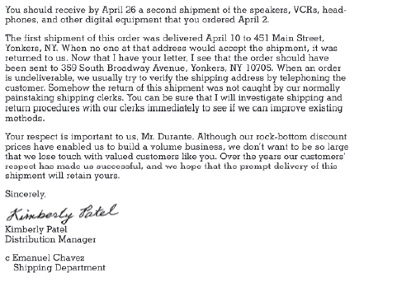

**Sample 2**



**Read the provided letter samples and analyze them by using the following pointers:**

1. Nature of the content in both samples
2. Tone (sad/happy/content/…)
3. How are the two samples structured content-wise?
4. Which letter is conveying positive message and which letter feels negative? Your reasons.